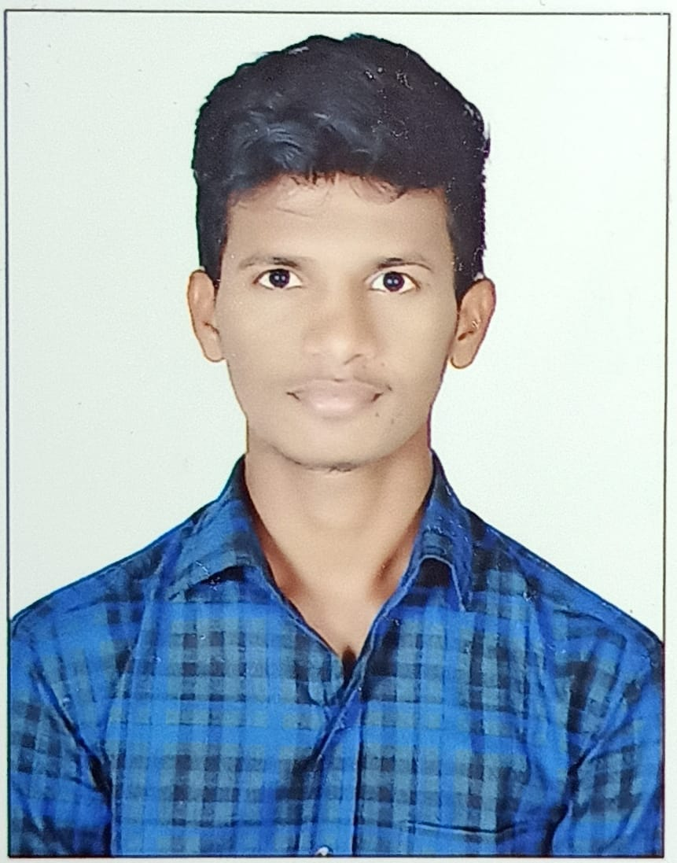

**CONTACT:**

Speaker Phone8096387204

[ndenkala@gmail.com](mailto:ndenkala@gmail.com) H.No:20-108/83,SLBC colony, Nakrekal, Nalgonda, Telangana -508211

**EDUCATION:**

* Pursuing ”B-Tech” (ECE)with “80%” from “Sri Indu college of engineering and technology”.
* Intermediate with “97%” from “Pragathi junior college” in 2019.
* S.S.C with “83%” from “A V M EM High School” in 2017.

**TECHNICAL SKILLS:**

* Basics of C
* Python
* HTML, CSS
* SQL
* Manual Testing

**ABILITIES:**

* Self-motivation
* Anger management
* Self-confidence
* Teamwork

**DENKALA NAVEEN**

**CAREER OBJECTIVE:**

A highly organized and hard working individual looking for a responsible position to gain practical experience and self-development.That helps me to achieve my personal and oraganizational goals.

**CO-CURRICULAR ACTIVITIES :**

* Participated in a ‘project expo’ on “IOT BASED HOME AUTOMATION”-2021
* Worked in project “snake robot”- which is used in spy purpose
* Worked in Project `Axis solar Tracking system with weather sensor’

Father Name :- Denkala Venkanna

Date of birth :30-01-2001

Languages Known: English

Hindi

Telugu

Hobbies : Watching videos, Playing games ,Listening Music

**PERSONAL DETAILS:**

**DECLARATION:**

I hereby declare that all the above information is correct and true.

Place: Hyderabad

Date:10/07/2023

**(DENKALA NAVEEN)**